**DBMS Lab Sheet 06 (2023.07.04)**

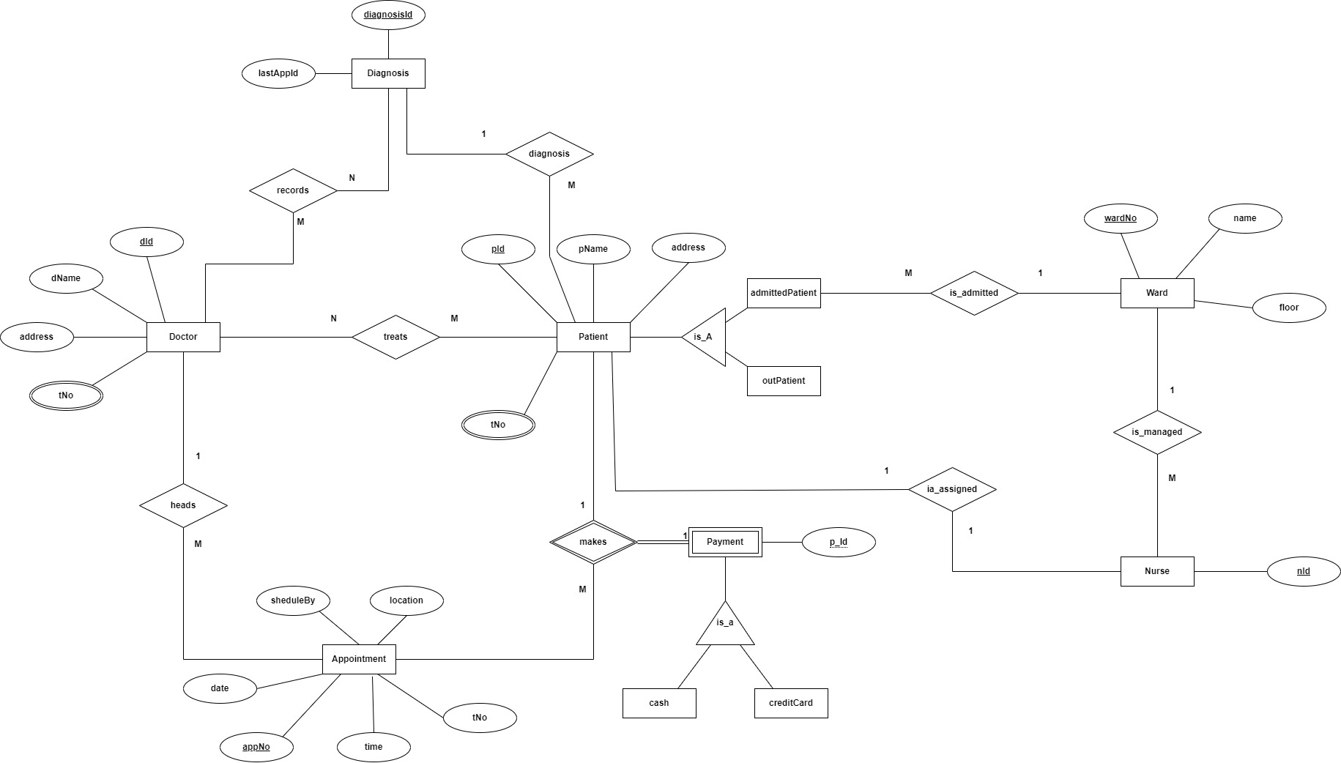

**Assumptions**

1. Assume that 1 appointment can be booked by only 1 patient.
2. Assume that 1 appointment is headed by only 1 doctor.
3. Assume that 1 doctor may record several diagnosis & 1 diagnoses may recorded by many doctors.
4. Assume that only 1 patient is diagnosis with only 1 diagnosis.